Retail Sales Data Processing and Business Insights Generation

PROJECT OVERVIEW
In today's retail industry, organizations generate large volumes of transactional data through both online and offline sales channels. This data contains valuable information related to customer purchasing behavior, product performance, revenue generation, and regional sales trends. However, raw retail data often contains issues such as missing values, duplicate records, inconsistent naming conventions, invalid entries, and sensitive customer information, making it unsuitable for direct analysis and reporting.

The objective of this project is to develop an end-to-end Retail Sales Data Processing and Business Insights Generation solution for ABC Retail Solutions. The solution focuses on ingesting, cleaning, transforming, validating, and securing retail transaction data to ensure data quality and reliability. Personally Identifiable Information (PII), including customer email addresses and phone numbers, is protected using masking techniques to maintain privacy and governance standards.

The project was implemented using Python, Pandas, SQLite, SQL, and Power BI. Raw retail transaction data from multiple source systems was processed through a structured data engineering pipeline, transformed into an analytics-ready dataset, and used to generate meaningful business KPIs. Interactive Power BI dashboards were developed to provide insights into revenue trends, product performance, category analysis, and regional sales performance, enabling data-driven business decision-making.

DATASET DESCRIPTION

The dataset used in this project consists of three Excel sheets containing retail transaction data and product reference information.

1.product_details
The product_details dataset serves as the product dimension table and contains standardized product information used for validation and enrichment of retail transaction records.

Number of Records: 10

This dataset was used as a reference table to validate product information and standardize product categories during data transformation.

2.retail_data1
The retail_data1 dataset contains retail transaction records collected from the first transactional source system.

Number of Records: 4,243

This dataset contains customer details, product information, transaction details, pricing information, payment methods, and purchase locations. Several data quality issues such as inconsistent category names, missing values, and varying formats were identified within this dataset.

3.retail_data2
The retail_data2 dataset contains retail transaction records collected from a second source system and follows a structure similar to retail_data1.

Number of Records: 4,251

This dataset contains the same business information as retail_data1 but includes additional inconsistencies such as mixed date formats, inconsistent product naming conventions, missing values, and duplicate records that required preprocessing before analysis.

Dataset Characteristics
The combined retail dataset contains transactional information related to customer purchases, products, payments, discounts, and geographical sales locations. During initial analysis, the following data quality challenges were observed:
- Missing values in selected columns
- Duplicate transaction records
- Inconsistent product names (e.g., "Laptop", "laptop", "LAPTOP")
- Inconsistent category values (e.g., "ELEC", "Electronics")
- Different date formats across datasets
- Sensitive customer information such as email addresses and phone numbers requiring PII masking
These issues were addressed through data cleaning, transformation, validation, and standardization processes before generating business insights and dashboards.

ARCHITECTURE DIAGRAM

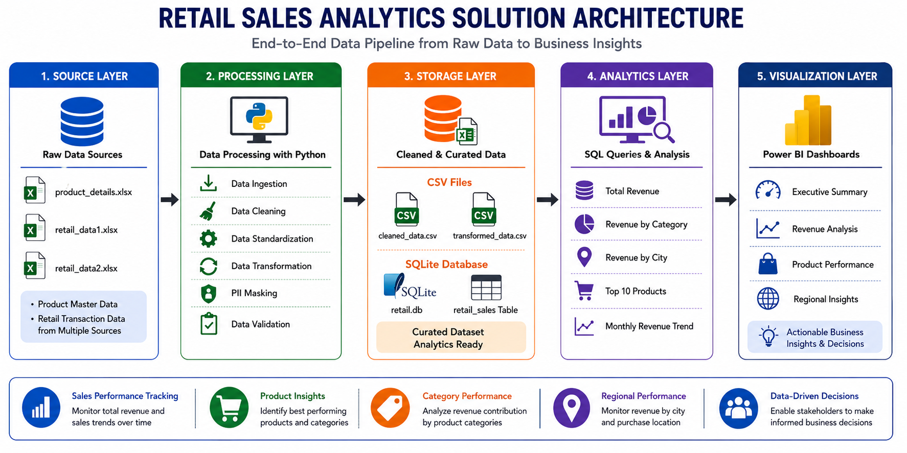

ARCHITECTURE FLOW

1. Source Layer
The source layer contains the raw input datasets used in the project:
- product_details.xlsx
- retail_data1.xlsx
- retail_data2.xlsx
These files contain product information and retail transaction records collected from multiple sources. The data includes customer details, product details, transaction information, payment methods, purchase locations, pricing information, discounts, and sales-related attributes.

2. Processing Layer
The processing layer is implemented using Python and Pandas to prepare the raw data for analysis.
i.Data Ingestion
Raw Excel files are loaded into Pandas DataFrames and consolidated into a unified dataset for processing.
ii. Data Cleaning
Missing values, duplicate records, and inconsistent data entries are identified and corrected to improve data quality.
iii. Data Standardization
Category names, product names, city names, and payment methods are standardized to ensure consistency across the dataset.
iv. Data Transformation
Business-ready attributes such as Revenue, Month, Quarter, and Year are generated to support analytical reporting.
v. PII Masking
Sensitive customer information, including email addresses and phone numbers, is masked to maintain data privacy and security.
vi. Data Validation
Quality checks are performed to verify data accuracy, completeness, and integrity before storing the final dataset.
This layer transforms raw transactional data into a clean, consistent, and analytics-ready dataset.

3. Storage Layer
After processing, the cleaned and transformed data is stored in structured formats for analysis and reporting.
The storage layer includes:
- cleaned_data.csv
- transformed_data.csv
- SQLite Database (retail.db)
- retail_sales table
This layer provides centralized storage, reliable data persistence, and efficient access to processed data for analytical operations.

4. Analytics Layer
The analytics layer utilizes SQL queries to generate meaningful business insights from the processed dataset.
Key analyses performed include:
- Total Revenue Analysis
- Revenue by Category
- Revenue by City
- Top 10 Products Analysis
- Monthly Revenue Trend Analysis
This layer converts processed data into valuable business metrics that support performance evaluation and decision-making.

5. Visualization Layer
The visualization layer uses Power BI to present analytical results through interactive dashboards.
The dashboards developed for this project include:
- Executive Summary
- Revenue Analysis
- Product Performance
- Regional Insights
These dashboards provide a comprehensive view of business performance, enabling users to monitor revenue trends, evaluate product performance, analyze regional sales, and make data-driven decisions.

DATA FLOW DIAGRAM

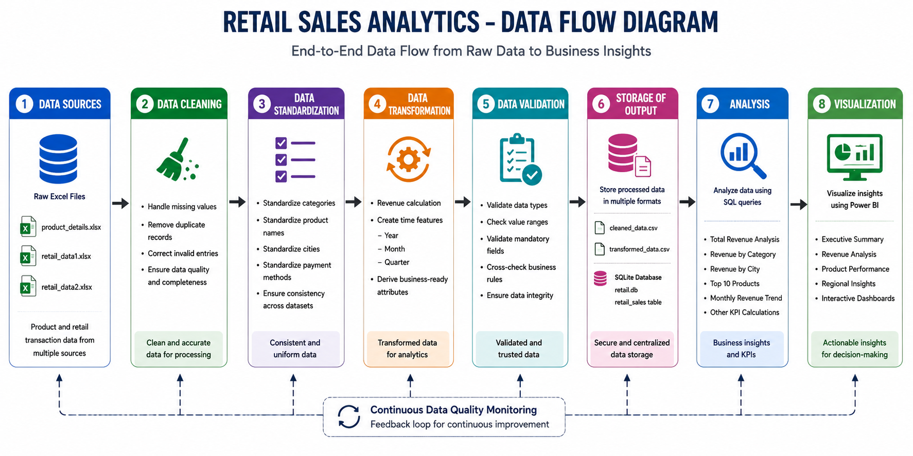

EXPLANATION:

1. Data Sources
The data flow begins with the raw retail datasets provided in Excel format.
Input Files
- product_details.xlsx
- retail_data1.xlsx
- retail_data2.xlsx
The Product Details dataset contains product-related information, while the retail datasets contain transaction records generated through customer purchases. These datasets include attributes such as Product ID, Product Name, Category, Customer Information, Transaction Date, Quantity, Price, Discount, Payment Method, Purchase Location, and City.
The datasets act as the primary source of information for the entire analytics solution.

2. Data Cleaning
After loading the datasets into Pandas DataFrames, data cleaning operations were performed to improve data quality and eliminate inconsistencies.
i.Missing Value Handling
The dataset was examined to identify missing values across all columns. Missing product prices were handled appropriately to ensure accurate revenue calculations.
ii. Duplicate Record Detection
Duplicate records were identified and removed to prevent duplicate transactions from affecting business metrics such as total revenue and transaction count.
iii.Invalid Data Correction
Records containing inconsistent or invalid values were reviewed and corrected wherever necessary to improve dataset reliability.
iv. Data Quality Assessment
General quality checks were performed to ensure completeness and usability of the dataset before moving to subsequent stages.
The output of this stage is a cleaner and more reliable dataset.

3. Data Standardization
The cleaned dataset was standardized to ensure consistency across all records.
i. Category Standardization
Different representations of the same category were mapped into a single standardized format.
ii. Product Name Standardization
Product names were converted into a consistent naming convention to avoid duplicate reporting caused by inconsistent capitalization or formatting.
iii. City Standardization
City names were standardized to maintain uniform reporting across regional analyses.
iv. Payment Method Standardization
Payment method values were standardized to ensure accurate categorization during dashboard reporting.
Standardization improved consistency and ensured that analytical results were not affected by formatting variations.

4. Data Transformation
The standardized dataset was transformed into an analytics-ready format by generating additional business attributes.
i.Product Master Dataset Assessment
The Product Master sheet was analyzed to verify whether additional product information was required. Since the transaction dataset already contained the necessary product attributes, no merge operation was performed, preventing redundant columns and duplicate information.
ii. Revenue Calculation
Revenue was calculated for each transaction using product price, quantity purchased, and discount information. This metric serves as the primary KPI used throughout the project.
iii. Time-Based Feature Engineering
Additional time attributes were derived from transaction dates, including:
- Year
- Month
- Quarter
These features enable monthly, quarterly, and yearly sales analysis.
iv. Business Dataset Preparation
The transformed dataset was structured to support KPI calculations, SQL analysis, and Power BI dashboard development.
At the end of this stage, the dataset became fully prepared for analytical processing.

5. Data Validation
Before storing the final dataset, several validation checks were performed to ensure data accuracy and integrity.
i.Price Validation
Product prices were checked to identify invalid or unrealistic values.
ii. Quantity Validation
Quantity fields were verified to ensure valid sales quantities.
iii. Discount Validation
Discount values were checked to ensure they remained within acceptable business limits.
iv. Duplicate Transaction Validation
Transaction identifiers were examined to detect duplicate transactions that could affect analytical results.
v. Integrity Verification
Additional quality checks were performed to confirm that the transformed dataset met business and reporting requirements.
These validation activities increased confidence in the reliability of the final dataset.

6. Storage of Output
After validation, the processed dataset was stored for future analysis and reporting.
CSV Storage
The cleaned and transformed datasets were exported as CSV files:
- cleaned_data.csv
- transformed_data.csv
Database Storage
The final dataset was loaded into a SQLite database and stored in the retail_sales table.
The storage layer provides centralized access to processed data and serves as the foundation for analytical operations.

7. Analysis
The stored data was analyzed using SQL queries to generate business insights and key performance indicators.
Key Analyses Performed:
- Total Revenue Analysis
- Revenue by Category
- Revenue by City
- Top 10 Product Analysis
- Monthly Revenue Trend Analysis
- Regional Sales Analysis
These analyses transformed processed data into meaningful business information.

8. Visualization
The final stage of the data flow involves visualizing analytical results using Power BI.
Executive Summary Dashboard
Provides high-level KPIs including total revenue, total transactions, average order value, and customer metrics.
Revenue Analysis Dashboard
Presents revenue trends, quarterly performance, payment method analysis, and purchase location analysis.
Product Performance Dashboard
Evaluates top-performing products, product contribution, quantity sold, and category performance.
Regional Insights Dashboard
Analyzes city-wise revenue, transaction distribution, regional performance, and purchase location trends.
The visualization layer converts analytical outputs into interactive dashboards that support business decision-making.

DATA MODEL
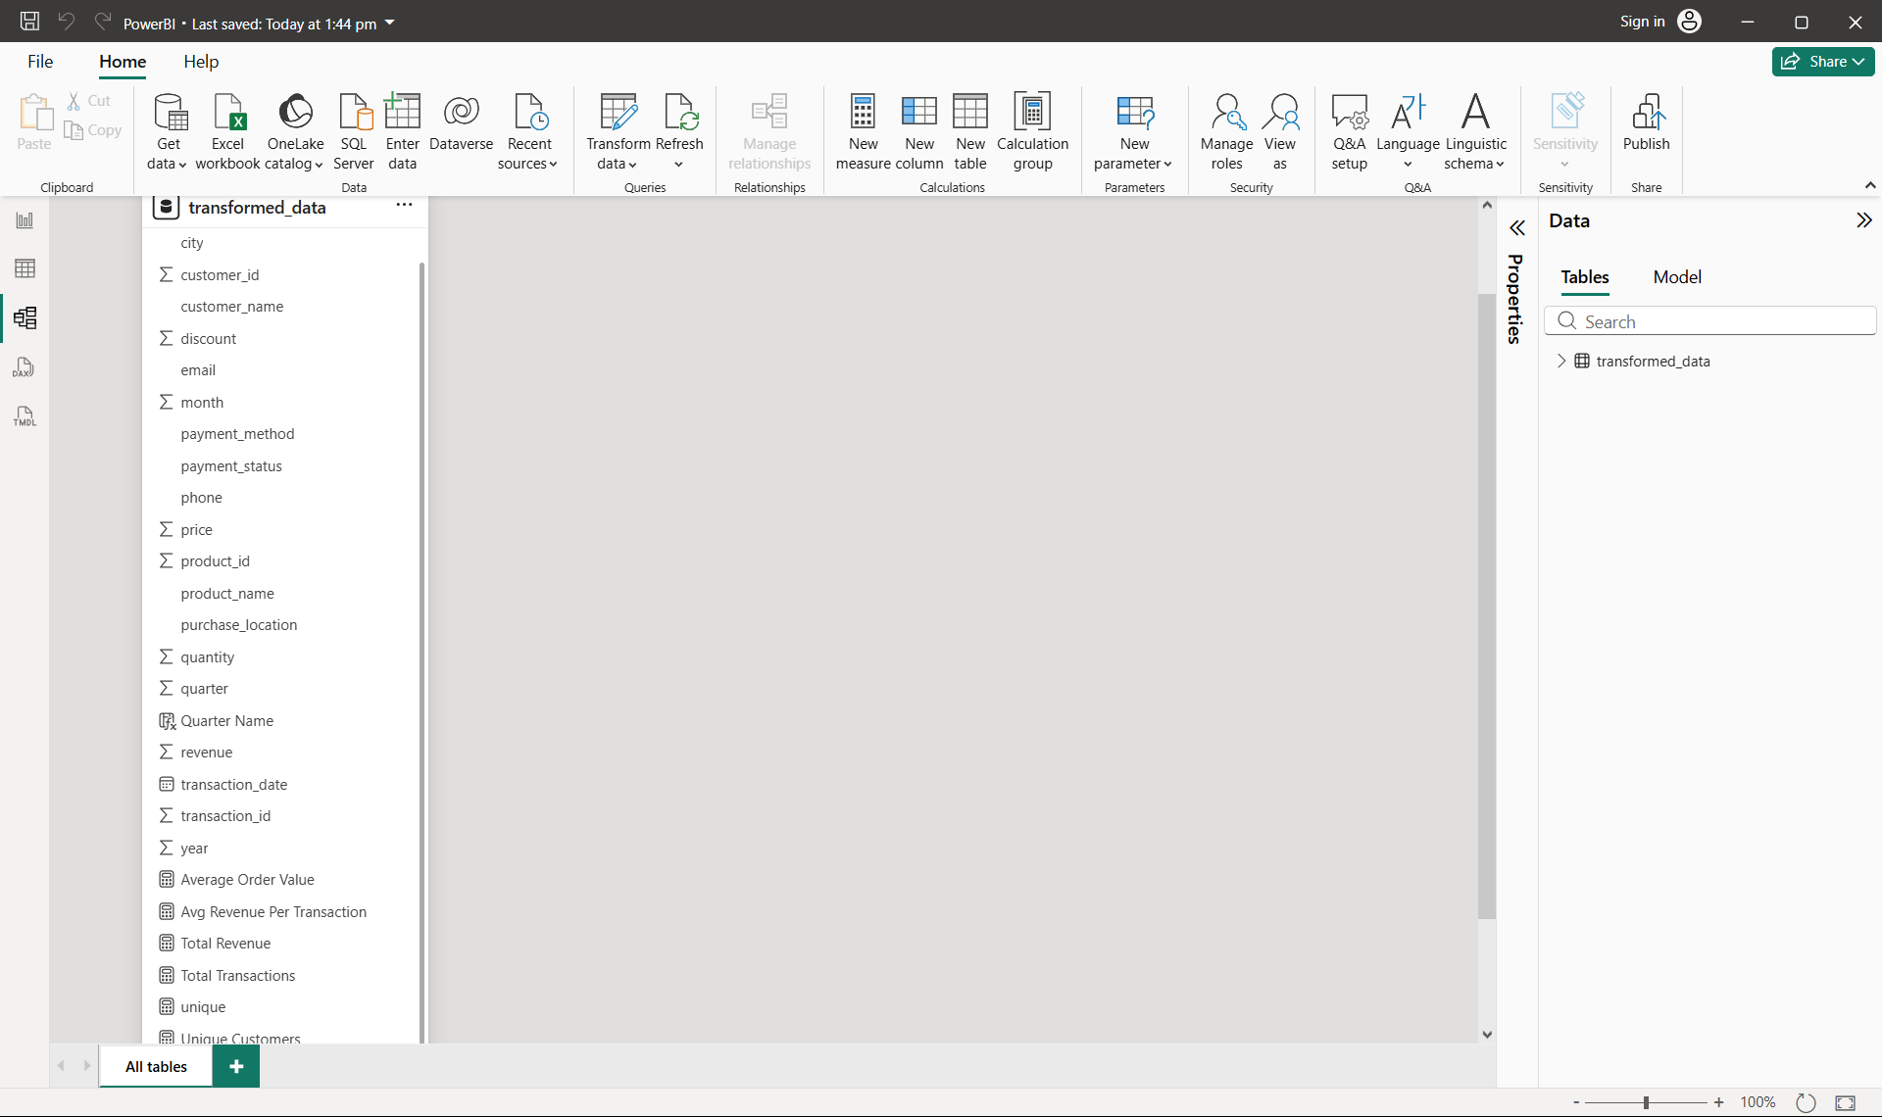

The data model represents the structure of the final analytics-ready dataset used for SQL analysis and Power BI dashboard development. After data cleaning, transformation, validation, and storage, all relevant information was consolidated into a single fact table named retail_sales.
The data model contains transaction-level information along with customer, product, location, and sales attributes required for KPI calculation and reporting.

Data Model Components:

Customer Attributes
The customer-related fields enable customer analysis and KPI calculations.
- Customer ID
- Customer Name
- Email Address (Masked)
- Phone Number (Masked)

Product Attributes
These attributes support product performance and category-level analysis.
- Product ID
- Product Name
- Category

Transaction Attributes
Transaction-specific fields provide information about customer purchases.
- Transaction ID
- Transaction Date
- Payment Method
- Payment Status
- Purchase Location

Sales Attributes
These fields are used to calculate revenue and performance metrics.
- Quantity
- Price
- Discount
- Revenue

Time Attributes
Time dimensions were generated during transformation to support trend analysis.
- Month
- Quarter
- Year

Location Attributes
Location-based fields support regional reporting.
- City
- Purchase Location

Calculated Measures
Several DAX measures were created within Power BI to support dashboard KPIs.
- Total Revenue
- Total Transactions
- Average Order Value
- Average Revenue Per Transaction
- Unique Customers

DATA CLEANING STRATEGY
Data quality plays a critical role in generating accurate business insights and reliable analytical reports. Therefore, a comprehensive data cleaning strategy was implemented before performing any transformation, validation, analysis, or visualization activities.

1.Missing Value Identification
The first step involved examining the dataset for missing values across all columns. A detailed assessment was performed to identify incomplete records and understand the extent of missing information within the dataset.
This analysis helped determine which attributes required further cleaning and corrective actions before analysis.

2.Missing Price Handling
During data quality assessment, missing values were observed in the Price column.
Instead of removing affected records, missing prices were populated using the average price of the corresponding product. This approach preserved valuable transaction records while ensuring accurate revenue calculations.
This strategy minimized data loss and improved the completeness of the dataset.

3.Duplicate Record Detection
The dataset was analyzed for duplicate records that could lead to inaccurate reporting and inflated business metrics.
Duplicate transaction records were identified and reviewed to ensure that the dataset maintained consistency and integrity before further processing.

4.Category Standardization
Category values appeared in multiple formats and abbreviations.
Examples:
- electronics
- ELEC
- Electronics
To ensure consistency across reports and dashboards, all category values were standardized into a common business-friendly format.
Examples:
- ELEC → Electronics
- FURN → Furniture
- CLOTH → Clothing
- HOME → Home Appliances
This standardization improved reporting accuracy and prevented duplicate category representations.

5.Product Name Standardization
Product names contained inconsistencies in capitalization and formatting.
Examples:
- PHONE
- phone
- Phone
All product names were converted into a consistent title-case format to improve data quality and eliminate duplicate product representations during analysis.

6.Date Format Standardization
Transaction dates were reviewed and converted into a standardized date format.
Invalid date values were automatically identified during the conversion process, allowing problematic records to be detected and reviewed.
Standardized dates ensured accurate monthly, quarterly, and yearly trend analysis.

7.Invalid Data Detection
The dataset was examined for invalid values that could negatively impact business analysis.
Checks were performed to identify:
- Invalid prices
- Invalid discounts
- Duplicate transaction identifiers
These checks helped improve dataset reliability and analytical accuracy.

8.Data Quality Assessment
General quality assessments were performed throughout the cleaning process to evaluate:
- Completeness
- Consistency
- Accuracy
- Reliability
This ensured that the cleaned dataset satisfied the quality standards required for transformation, validation, SQL analysis, and dashboard development.

9. PII Masking
To protect customer privacy, sensitive information such as email addresses and phone numbers was masked before analysis and reporting.
Email Masking
Before:
- johnsmith@gmail.com
After:
- jo****@gmail.com
Phone Number Masking
Before:
- 9876543210
After:
- ******3210

TRANSFORMATION LOGIC
Data transformation was performed to convert the cleaned dataset into an analytics-ready format suitable for reporting and dashboard development.

1. Product Master Dataset Assessment
The Product Master sheet was analyzed to determine whether additional product information was required for analysis.
Since the transaction dataset already contained the necessary product-related attributes, no merge operation was performed. This helped avoid redundant columns and unnecessary data duplication.

2. Revenue Calculation
A new Revenue column was created using the following formula:
Revenue = Price × Quantity × (1 − Discount)
This became the primary business metric used throughout the project for sales analysis, KPI generation, and dashboard reporting.

3. Time Feature Generation
Additional time-based attributes were derived from the transaction date.
The following fields were created:
- Year
- Month
- Quarter
These attributes support monthly, quarterly, and yearly trend analysis within Power BI.

4. Analytical Dataset Preparation
The transformed dataset was structured to support SQL analysis, KPI calculations, and Power BI dashboard development.
The final dataset contains customer, product, transaction, location, revenue, and time-related attributes required for business reporting.

5. KPI Support
The transformed dataset supports the calculation of several business KPIs, including:
- Total Revenue
- Total Transactions
- Unique Customers
- Average Order Value
- Revenue by Category
- Revenue by City
- Revenue by Product
- Quantity Sold by Product

VISUAL INSIGHTS

RETAIL SALES PERFORMANCE DASHBOARD

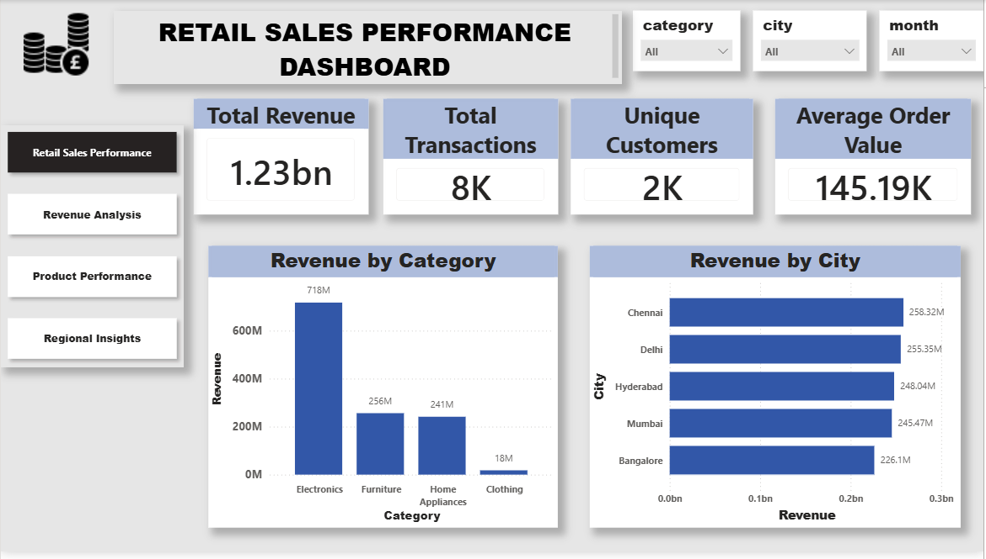

INSIGHTS:
- The business generated 1.23 Billion revenue from 8K transactions.
- Electronics is the top-performing category, contributing the highest revenue.
- Chennai recorded the highest revenue among all cities.
- The business serves 2K unique customers, indicating a strong customer base.
- The Average Order Value of 145.19K reflects healthy customer spending patterns.

REVENUE ANALYSIS

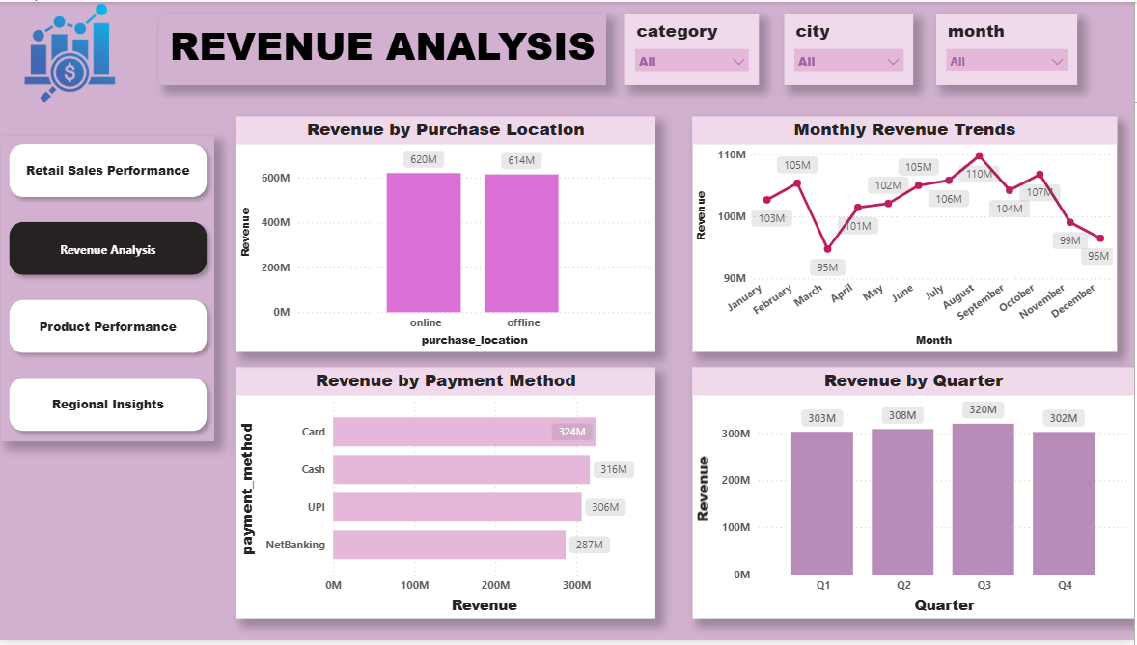

INSIGHTS:
- Q3 recorded the highest revenue, indicating the strongest sales performance.
- Card payments generated the highest revenue among all payment methods.
- Online and offline sales contribute almost equally to total revenue.
- Revenue remained relatively stable throughout the year with minor monthly fluctuations.

PRODUCT PERFORMANCE
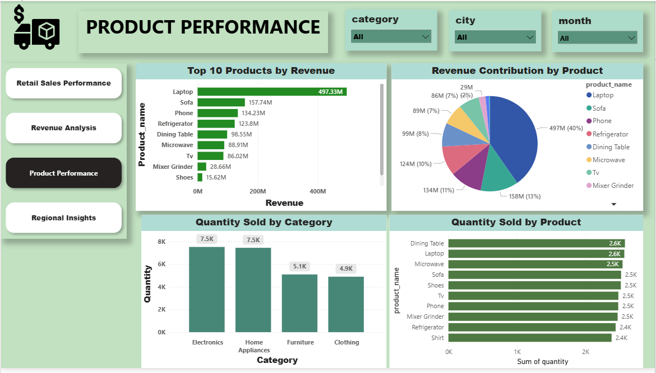

INSIGHTS:
- Laptop is the top revenue-generating product.
- Electronics contributes the highest quantity sold among categories.
- A few products contribute a major share of total revenue.
- Product-wise analysis highlights the best-selling and most profitable products.

REGIONAL DASHBOARD
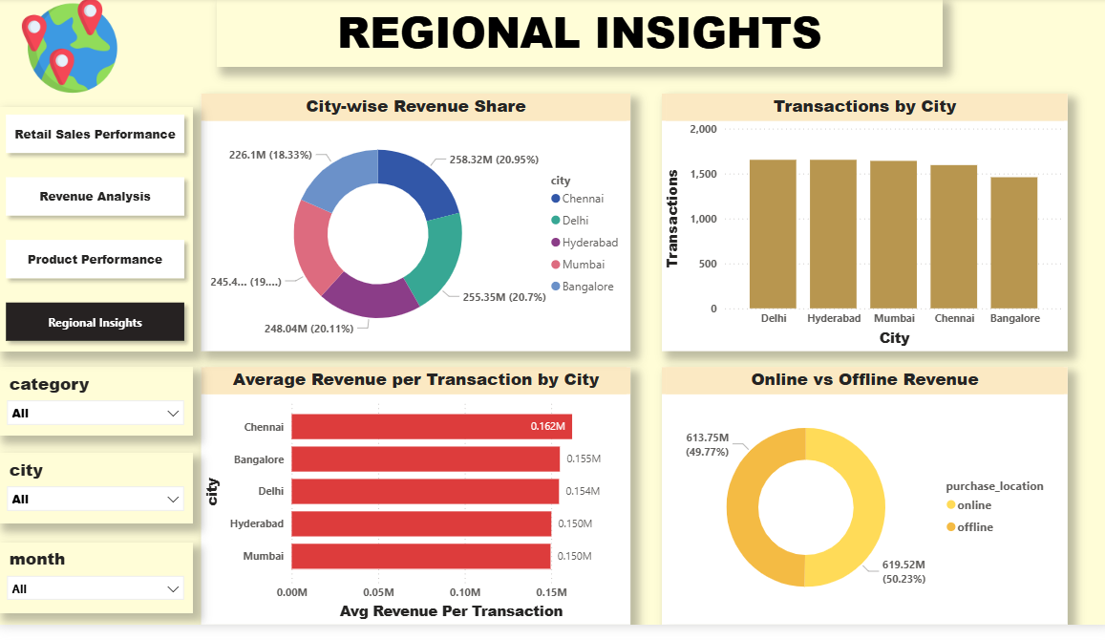

INSIGHTS:
- Chennai contributes the highest revenue and average revenue per transaction.
- Revenue is fairly distributed across cities, indicating balanced regional performance.
- Transaction volumes are similar across major cities, showing consistent customer activity.
- Online and offline channels contribute almost equally to total revenue.

